**INSTALLATION MANUAL**

|  |
| --- |
| **PRODUCT NAME:**  **3 INCH Spyder Spoiler Bar for FORD RANGER 2022+** |

|  |  |
| --- | --- |
| **一、ATTENTION** |  |

1.For the convenience of installation,please read the product installation manual carefully before installation.Pay attention to protect surface of your car to avoid scratches.

2.Please check regularly whether all accessories connected to the car are loose or not to ensure safety using.

3.All the pictures in this manual are for reference only.The pictures may be different from the actual product,but the installation method is the same.

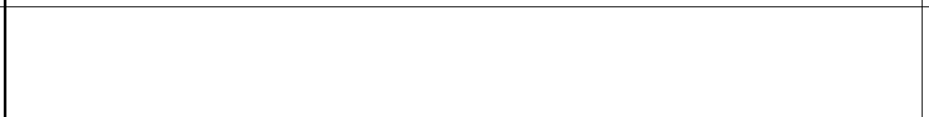**二、ACCESSORIES**

|  |  |  |  |
| --- | --- | --- | --- |
| **NO.** | **ITEM** | **QTY** | **PICTURE** |
|  | **Head mounting body** | **1** |  |
|  | **Fence mounting body** | **1** |  |
| **3** | **Bracket (left and rignt)** | **1** |  |
|  | **flat washerφ10*25*2.5** | **6** |  |
|  | **spring washerφ10** | **4** |  |

|  |  |  |  |
| --- | --- | --- | --- |
| **NO.** | **ITEM** | **QTY** | **PICTURE** |
|  | **Hexagon head nuts M10** | **2** |  |
|  | **Hexagonal head bolts M10*35** | **4** |  |

|  |
| --- |
|  |
| EFFECT PICTURE2 |



**三、** **INSTALLATION INSTRUCTION**

|  |
| --- |
|  |
|  |
| **EFFECT PICTURE1** |

|  |
| --- |
|  |